Woodman, N. (2023). Skeletal indicators of locomotor adaptations in shrews. Therya, 14(1), 15-37.

Supplementary Table S1. Mean values of measurements (See Table 1 for abbreviations).
_____________________________________________________________________________
ID | Mode | SL | HL | HDW | HDPC | HLD | HTTR | HAR | HTT | RL | RDW
Chimarrogale himalayaca | SA | 11.21 | 11.97 | 4.11 | 5.37 | 0.98 | 1.06 | 11.45 | 4.82
Nectogale elegans | SA | 13.21 | 12.27 | 5.88 | 5.16 | 1.44 | 1.56 | 11.70 | 4.31 | 13.38 | 1.95
Neomys fodiens | SA | 9.07 | 8.82 | 3.62 | 3.91 | 0.82 | 1.41 | 8.47 | 3.54 | 9.09 | 1.08
Sorex albibarbis | SA | 8.26 | 8.88 | 3.12 | 3.42 | 0.79 | 1.15 | 8.52 | 3.15 | 9.36 | 1.05
Sorex bendirii | SA | 9.76 | 9.86 | 3.74 | 3.96 | 0.97 | 1.56 | 9.40 | 3.99 | 10.45 | 1.29
Sorex navigator | SA | 8.34 | 8.79 | 3.23 | 3.30 | 0.78 | 1.33 | 8.37 | 3.25 | 9.46 | 1.10
Sorex palustris | SA | 6.73 | 7.88 | 2.48 | 3.24 | 0.69 | 1.05 | 6.74 | 2.90 | 9.36 | 1.02
Sorex cinereus | Am | 5.68 | 6.04 | 1.92 | 2.32 | 0.50 | 0.75 | 5.87 | 2.03 | 6.37 | 0.65
Sorex hoyi | Am | 4.75 | 5.20 | 1.69 | 2.09 | 0.41 | 0.73 | 5.00 | 1.91 | 5.29 | 0.61
Sorex sonomae | Am | 7.97 | 8.20 | 3.00 | 3.23 | 0.79 | 1.12 | 7.83 | 3.04 | 8.85 | 1.02
Suncus hututsi | Am
Cryptotis parvus | Am | 6.21 | 6.20 | 2.23 | 2.63 | 0.54 | 1.00 | 5.95 | 2.39 | 6.36 | 0.82
Cryptotis tropicalis | Am | 6.87 | 6.83 | 2.31 | 3.09 | 0.67 | 1.16 | 6.61 | 2.77 | 7.00 | 0.88
Cryptotis merriami | Am | 7.33 | 7.77 | 2.69 | 3.44 | 0.74 | 1.24 | 7.43 | 2.80 | 7.24 | 0.87
Cryptotis merus | Am | 7.09 | 7.56 | 2.71 | 3.48 | 0.66 | 0.90 | 7.30 | 2.70
Cryptotis nigrescens | Am | 7.38 | 7.89 | 2.76 | 3.37 | 0.71 | 1.39 | 7.59 | 2.96 | 6.89 | 0.87
Blarinella quadricaudata | Am | 7.23 | 7.21 | 2.83 | 3.11 | 0.71 | 1.43 | 6.86 | 3.14 | 7.80 | 0.99
Crocidura olivieri | Am |  | 14.12 | 3.87 | 7.05 | 1.21 | 1.09 | 13.89 | 5.10
Crocidura religiosa | Am |  | 5.77 | 1.59 | 3.00 | 0.41 | 0.35 | 5.70 | 2.03
Crocidura suaveolens | Am |  | 7.91 | 2.43 | 3.74 | 0.62 | 0.88 | 7.73 | 2.73
Myosorex cafer | Am | 8.93 | 9.75 | 3.11 | 4.46 | 0.94 | 1.41 | 9.46 | 3.42
Myosorex geata | Am | 8.43 | 8.99 | 3.16 | 4.23 | 0.82 | 1.40 | 8.73 | 3.37
Myosorex kihaulei | Am | 8.53 | 9.04 | 3.15 | 4.20 | 0.86 | 1.37 | 8.77 | 3.47
Blarina brevicauda talpoides | SF | 9.67 | 9.15 | 3.97 | 4.09 | 1.06 | 2.03 | 8.88 | 4.02 | 8.40 | 1.39
Blarina brevicauda jerryrchoatei | SF | 9.31 | 8.46 | 3.76 | 3.84 | 1.07 | 1.98 | 8.44 | 3.91 | 7.79 | 1.30
Blarina carolinensis | SF | 8.12 | 7.41 | 3.31 | 3.54 | 0.87 | 1.59 | 7.41 | 3.30 | 7.08 | 1.01
Blarina hylophaga | SF
Blarina peninsulae | SF | 8.06 | 7.53 | 3.30 | 3.70 | 0.88 | 1.41 | 7.36 | 3.34 | 7.11 | 1.08
Blarina shermani | SF
Blarina brevicauda jknoxjonesi | SF
Cryptotis mexicanus | SF | 8.06 | 7.29 | 3.32 | 3.19 | 0.79 | 1.69 | 6.82 | 3.35
Cryptotis phillipsii | SF |  | 7.77 | 3.25 | 3.27 | 0.83 | 1.68 | 7.38 | 3.13
Cryptotis eckerlini | SF | 8.76 | 7.77 | 4.25 | 3.85 | 0.97 | 2.22 | 7.52 | 3.67 | 8.06 | 1.27
Cryptotis matsoni | SF | 9.29 | 7.70 | 4.22 | 3.79 | 0.97 | 2.50 | 7.62 | 4.00
Cryptotis cavatorculus | SF |  | 8.35 | 4.34 | 4.18 | 1.04 | 2.50 | 7.88 | 3.79 | 8.08 | 1.24
Cryptotis celaque | SF | 8.84 | 7.89 | 3.99 | 3.54 | 0.99 | 2.29 | 7.38 | 3.61 | 8.42 | 1.18
Cryptotis mam | SF | 8.83 | 7.81 | 4.02 | 3.60 | 1.02 | 2.37 | 7.37 | 3.78 | 8.32 | 1.32
Cryptotis magnimanus | SF |  | 8.27 | 4.50 | 3.55 | 1.07 | 2.32 | 7.86 | 3.92
Cryptotis mccarthyi | SF |  | 8.04 | 4.08 | 3.48 | 1.04 | 2.25 | 7.55 | 3.45
Congosorex phillipsorum | SF | 8.09 | 7.82 | 3.31 | 3.88 | 0.88 | 1.49 | 7.66 | 2.98
Myosorex blarina | SF | 9.81 | 9.80 | 3.83 | 4.93 | 0.88 | 1.82 | 9.61 | 3.99 | 9.45 | 1.44
Myosorex varius | SF | 9.39 | 9.50 | 3.32 | 4.52 | 0.97 | 1.62 | 9.20 | 3.96 | 9.78 | 1.26
Myosorex zinki | SF | 10.53 | 9.78 | 4.62 | 4.60 | 1.25 | 1.77 | 9.76 | 4.06
Cryptotis lacertosus | SF | 10.87 | 8.83 | 5.09 | 3.87 | 1.32 | 2.70 | 8.17 | 4.15 | 9.01 | 1.54
Cryptotis oreoryctes | SF | 9.63 | 8.29 | 4.46 | 3.66 | 1.11 | 2.63 | 7.78 | 3.96 | 8.60 | 1.31
Surdisorex norae | F | 12.08 | 10.08 | 6.01 | 6.30 | 1.75 | 3.46 | 9.95 | 5.07 | 10.43 | 1.81
Surdisorex polulus | F | 11.38 | 10.07 | 5.81 | 6.22 | 1.68 | 3.70 | 9.56 | 5.30
Cryptotis gracilis | UN | 7.52 | 7.07 | 3.10 | 3.23 | 0.77 | 1.40 | 6.73 | 3.06
Cryptotis endersi | UN | 8.22 | 8.59 | 3.57 | 3.61 | 0.77 | 1.67 | 8.33 | 3.42
Cryptotis meridensis | UN | 8.22 | 8.44 | 3.38 | 3.70 | 0.86 | 1.49 | 8.04 | 3.58 | 8.73 | 1.21
Cryptotis monteverdensis | UN |  | 8.33 | 3.58 | 3.61 | 0.82 | 1.45 | 7.95 | 3.63
Cryptotis thomasi | UN | 8.93 | 8.83 |  | 3.85 | 0.95 | 1.92 | 8.04 | 3.57
Number of species |  | 40 | 48 | 47 | 48 | 48 | 48 | 48 | 48 | 28 | 28

ID | Mode | UL | UFL | UOP | UPC | ULD | FL | FDW | FLD | TL | TDA | TDW | 3MW
C. himalayaca | SA |  |  |  |  |  |  |  |  |  |  |  | 0.46
N. elegans | SA | 18.10 | 13.00 | 3.15 | 3.37 | 0.67 | 13.37 | 4.70 | 1.55 | 24.35 | 1.84 | 3.58 | 0.49
N. fodiens | SA | 12.31 | 9.29 | 1.95 | 2.12 | 0.46 | 10.29 | 2.64 | 0.92 | 17.56 | 1.11 | 2.41 | 0.36
S. albibarbis | SA | 12.16 | 9.35 | 1.81 | 2.39 | 0.47 | 9.46 | 2.69 | 0.93 | 17.38 | 0.92 | 2.22 | 0.32
S. bendirii | SA | 13.89 | 10.33 | 2.35 | 2.86 | 0.63 | 10.83 | 3.02 | 1.10 | 19.24 | 1.34 | 2.57 | 0.36
S. navigator | SA | 12.42 | 9.43 | 1.99 | 2.39 | 0.51 | 9.60 | 2.77 | 0.97 | 17.79 | 1.15 | 2.35 | 0.33
S. palustris | SA | 8.39 | 7.08 | 1.48 | 2.09 | 0.49 | 7.76 | 2.25 | 1.25 | 11.87 | 2.94 | 1.64 | 0.35
S. cinereus | Am | 8.24 | 6.25 | 1.23 | 1.45 | 0.32 | 6.72 | 1.65 | 0.61 | 11.92 | 0.82 | 1.49 | 0.19
S. hoyi | Am | 6.88 | 5.21 | 1.06 | 1.29 | 0.26 | 5.79 | 1.48 | 0.43 | 9.81 | 0.66 | 1.23 | 0.17
S. sonomae | Am | 11.56 | 8.64 | 1.76 | 2.28 | 0.48 | 9.14 | 2.46 | 0.83 | 16.02 | 1.08 | 2.11 | 0.35
Su. hututsi | Am |  |  |  |  |  |  |  |  |  |  |  | 0.40
C. parvus | Am | 8.26 | 6.16 | 1.10 | 1.45 | 0.35 | 7.22 | 1.64 | 0.59 | 10.48 | 0.58 | 1.41 | 0.21
C. tropicalis | Am | 9.23 | 7.06 | 1.23 | 1.69 | 0.42 | 7.84 | 1.64 | 0.62 | 11.57 | 0.68 | 1.57 | 0.25
C. merriami | Am | 9.63 | 7.04 | 1.41 | 1.89 | 0.47 | 8.47 | 1.85 | 0.83 | 12.08 | 0.71 | 1.64 | 0.24
C. merus | Am |  |  |  |  |  | 8.55 | 1.88 | 0.78 | 11.86 | 0.75 | 1.83 | 0.27
C. nigrescens | Am | 9.23 | 6.78 | 1.37 | 1.93 | 0.48 | 8.59 | 1.90 | 0.81 | 11.72 | 0.74 | 1.60 | 0.31
Bl. quadricaudata | Am | 10.35 | 7.77 | 1.68 | 1.86 | 0.46 | 7.84 | 2.00 | 0.76 | 12.49 | 0.89 | 1.85 | 0.30
Cr. olivieri | Am |  |  |  |  |  | 13.87 | 2.95 | 1.42
Cr. religiosa | Am |  |  |  |  |  | 6.33 | 1.31 | 0.57
Cr. suaveolens | Am | 7.58 | 5.94 | 1.04 | 1.18 | 0.38 | 9.07 | 1.90 | 0.74 | 11.25 | 0.43 | 1.47
M. cafer | Am |  |  |  |  |  | 11.09 | 2.35 | 0.93 |  |  |  | 0.43
M. geata | Am |  |  |  |  |  | 9.88 | 2.30 | 0.98 |  |  |  | 0.41
M. kihaulei | Am |  |  |  |  |  | 10.08 | 2.30 | 0.99 |  |  |  | 0.39
B. b. talpoides | SF | 12.10 | 8.40 | 2.69 | 2.98 | 0.67 | 10.34 | 2.68 | 1.01 | 14.10 | 1.18 | 2.27 | 0.44
B. b. jerryrchoatei | SF | 11.12 | 7.72 | 2.26 | 2.75 | 0.58 | 9.59 | 2.41 | 0.97 | 12.78 | 1.09 | 1.95 | 0.45
B. carolinensis | SF | 9.95 | 7.17 | 1.99 | 2.18 | 0.52 | 8.59 | 2.19 | 0.80 | 11.79 | 0.59 | 1.73 | 0.30
B. hylophaga | SF |  |  |  |  |  |  |  |  |  |  |  | 0.41
B. peninsulae | SF | 10.33 | 7.34 | 2.12 | 2.34 | 0.56 |  |  |  | 11.77 | 0.88 | 1.98 | 0.36
B. shermani | SF |  |  |  |  |  |  |  |  |  |  |  | 0.37
B. b. jknoxjonesi | SF |  |  |  |  |  |  |  |  |  |  |  | 0.40
C. mexicanus | SF |  |  |  |  |  |  |  |  |  |  |  | 0.37
C. phillipsii | SF
C. eckerlini | SF | 9.03 | 5.83 | 2.43 | 2.80 | 0.67 | 9.14 | 2.53 | 0.90 |  |  |  | 0.47
C. matsoni | SF |  |  |  |  |  | 9.67 | 2.59 | 0.93
C. cavatorculus | SF | 11.63 | 8.17 | 2.32 | 2.77 | 0.55 |  |  |  |  |  |  | 0.52
C. celaque | SF | 12.16 | 8.33 | 2.17 | 2.75 | 0.66 | 9.00 | 2.51 | 0.83 |  |  |  | 0.45
C. mam | SF | 11.80 | 8.16 | 2.01 | 2.70 | 0.58 | 8.89 | 2.33 | 0.79 | 13.59 | 0.88 | 1.99 | 0.42
C. magnimanus | SF
C. mccarthyi | SF |  |  |  |  |  |  |  |  |  |  |  | 0.47
Co. phillipsorum | SF |  |  |  |  |  | 8.65 | 2.11 | 0.85 |  |  |  | 0.40
M. blarina | SF | 13.08 | 9.54 | 2.30 | 2.97 | 0.77 | 11.05 | 2.64 | 1.08 | 15.68 | 1.04 | 2.28 | 0.50
M. varius | SF | 12.84 | 9.84 | 1.89 | 2.94 | 0.53 | 11.08 | 2.41 | 0.98 | 16.46 | 0.96 | 2.11 | 0.48
M. zinki | SF |  |  |  |  |  | 11.94 | 2.93 | 1.26 |  |  |  | 0.61
C. lacertosus | SF | 13.31 | 8.83 | 2.46 | 3.57 | 0.80 | 9.58 | 2.73 | 0.94 | 14.08 | 1.07 | 2.22 | 0.53
C. oreoryctes | SF | 12.34 | 8.23 | 2.39 | 3.01 | 0.61 | 9.91 | 2.66 | 0.93 | 15.40 | 1.07 | 2.16 | 0.47
Sur. norae | F | 15.37 | 10.46 | 3.28 | 4.14 | 0.94 | 12.48 | 3.13 | 1.41 | 16.83 | 1.25 | 2.81 | 0.74
Sur. polulus | F |  |  |  |  |  | 12.02 | 2.93 | 1.24 |  |  |  | 0.80
C. gracilis | UN |  |  |  |  |  | 7.74 | 2.10 | 0.81 | 13.57 | 0.84 | 1.95 | 0.30
C. endersi | UN |  |  | 1.76 | 2.30 | 0.56 | 9.53 | 2.59 | 0.89
C. meridensis | UN | 11.83 | 8.56 | 1.81 | 2.23 | 0.54 | 9.38 | 2.34 | 0.84 | 15.52 | 0.92 | 2.08 | 0.36
C. monteverdensis | UN
C. thomasi | UN |  |  |  |  |  | 9.84 | 2.31 | 0.95 |  |  |  | 0.38
No. of spp. |  | 29 | 29 | 30 | 30 | 30 | 40 | 40 | 40 | 28 | 28 | 28 | 44

ID | Mode | 3ML | 3PPW | 3PPL | 3MPW | 3MPL | 3DPW | 3DPL | 3CW | 3CL | 3hMW | 3hML
C. himalayaca | SA | 4.69 | 0.42 | 2.85 | 0.34 | 1.53 | 0.46 | 1.39 | 0.29 | 2.14 | 0.60 | 8.37
N. elegans | SA | 5.87 | 0.42 | 2.84 |  |  | 0.52 | 1.57 | 0.33 | 2.44 | 0.59 | 11.74
N. fodiens | SA | 4.14 | 0.33 | 2.29 | 0.29 | 1.41 | 0.46 | 1.12 | 0.30 | 2.11 | 0.48 | 7.36
S. albibarbis | SA | 3.63 | 0.30 | 2.02 | 0.27 | 1.22 | 0.38 | 0.98 | 0.23 | 1.82 | 0.42 | 7.11
S. bendirii | SA | 3.84 | 0.36 | 2.03 | 0.33 | 1.23 | 0.47 | 1.18 | 0.29 | 2.33 | 0.44 | 7.28
S. navigator | SA | 3.75 | 0.31 | 2.14 | 0.31 | 1.26 | 0.43 | 1.20 | 0.27 | 2.22 | 0.46 | 7.38
S. palustris | SA | 3.90 | 0.33 | 2.03 | 0.31 | 1.24 | 0.43 | 1.08 | 0.26 | 2.17 | 0.45 | 7.07
S. cinereus | Am | 2.31 | 0.18 | 1.26 | 0.17 | 0.81 | 0.26 | 0.62 | 0.14 | 1.19 | 0.26 | 4.28
S. hoyi | Am | 2.03 | 0.16 | 1.12 | 0.15 | 0.78 | 0.23 | 0.58 | 0.12 | 1.18 | 0.22 | 3.29
S. sonomae | Am | 3.48 | 0.32 | 1.93 | 0.30 | 1.30 | 0.44 | 1.15 | 0.26 | 2.32 | 0.42 | 5.89
Su. hututsi | Am | 4.13 | 0.35 | 2.25 | 0.31 | 1.30 | 0.40 | 0.78 | 0.25 | 1.46 | 0.50 | 5.99
C. parvus | Am | 2.25 | 0.21 | 1.21 | 0.20 | 0.85 | 0.31 | 0.67 | 0.17 | 1.51 | 0.23 | 3.35
C. tropicalis | Am | 2.48 | 0.24 | 1.48 | 0.21 | 0.95 | 0.26 | 0.63 | 0.17 | 1.48 | 0.29 | 3.74
C. merriami | Am | 2.50 | 0.28 | 1.54 | 0.26 | 0.92 | 0.35 | 0.75 | 0.26 | 1.43 | 0.39 | 3.70
C. merus | Am | 2.75 | 0.27 | 1.57 | 0.24 | 0.96 | 0.22 | 0.71 | 0.26 | 1.57 | 0.42 | 3.88
C. nigrescens | Am | 2.70 | 0.27 | 1.60 | 0.27 | 0.94 | 0.40 | 0.82 | 0.21 | 1.62 | 0.40 | 3.70
Bl. quadricaudata | Am | 2.76 | 0.25 | 1.65 | 0.25 | 1.21 | 0.35 | 1.10 | 0.24 | 2.18 | 0.33 | 3.89
Cr. olivieri | Am
Cr. religiosa | Am
Cr. suaveolens | Am
M. cafer | Am | 3.81 | 0.37 | 2.08 | 0.34 | 1.38 | 0.52 | 1.35 | 0.32 | 2.64 | 0.51 | 5.36
M. geata | Am | 3.29 | 0.38 | 1.76 | 0.38 | 1.19 | 0.48 | 1.31 | 0.32 | 2.63 | 0.50 | 4.56
M. kihaulei | Am | 3.30 | 0.37 | 1.73 | 0.36 | 1.18 | 0.49 | 1.41 | 0.39 | 2.87 | 0.51 | 4.73
B. b. talpoides | SF | 3.18 | 0.39 | 1.73 | 0.39 | 1.10 | 0.54 | 1.37 | 0.40 | 2.61 | 0.49 | 4.29
B. b. jerryrchoatei | SF | 3.14 | 0.44 | 1.76 | 0.42 | 1.00 | 0.51 | 1.33 | 0.41 | 2.43 | 0.47 | 4.31
B. carolinensis | SF | 2.25 | 0.30 | 1.38 | 0.28 | 0.83 | 0.41 | 1.05 | 0.32 | 2.00 | 0.36 | 3.49
B. hylophaga | SF | 2.87 | 0.37 | 1.66 | 0.36 | 1.01 | 0.48 | 1.32 | 0.37 | 2.51 | 0.46 | 4.16
B. peninsulae | SF | 2.85 | 0.31 | 1.64 | 0.32 | 0.98 | 0.42 | 1.23 | 0.36 | 2.41 | 0.40 | 4.06
B. shermani | SF | 2.82 | 0.38 | 1.66 | 0.38 | 1.13 | 0.47 | 1.19 | 0.35 | 2.47 | 0.42 | 4.23
B. b. jknoxjonesi | SF | 3.03 | 0.40 | 1.68 | 0.39 | 1.00 | 0.51 | 1.31 | 0.41 | 2.65 | 0.60 | 4.20
C. mexicanus | SF | 2.57 | 0.35 | 1.47 | 0.35 | 0.83 | 0.25 | 1.28 |  | 2.32
C. phillipsii | SF
C. eckerlini | SF | 2.53 | 0.47 | 1.53 | 0.45 | 1.11 | 0.60 | 1.78 | 0.45 | 3.25 | 0.48 | 4.13
C. matsoni | SF | 2.63 | 0.47 | 1.35 | 0.51 | 1.12 | 0.64 | 1.72 | 0.49 | 3.04 | 0.41 | 4.42
C. cavatorculus | SF | 2.74 | 0.49 | 1.63 | 0.53 | 0.91 | 0.74 | 1.93 | 0.52 | 3.18 | 0.53 | 3.98
C. celaque | SF | 2.70 | 0.44 | 1.49 | 0.45 | 0.78 | 0.56 | 1.66 | 0.43 | 2.90 | 0.46 | 3.98
C. mam | SF | 2.56 | 0.43 | 1.54 | 0.44 | 0.93 | 0.61 | 1.74 | 0.46 | 3.13 | 0.45 | 3.97
C. magnimanus | SF
C. mccarthyi | SF | 2.44 | 0.46 | 1.43 | 0.49 | 0.79 | 0.61 | 1.64 | 0.44 | 2.88 | 0.49 | 3.78
Co. phillipsorum | SF | 3.03 | 0.35 | 1.68 | 0.35 | 0.95 | 0.48 | 1.32 | 0.37 | 2.22 | 0.47 | 3.99
M. blarina | SF | 3.41 | 0.54 | 1.71 | 0.46 | 1.15 | 0.60 | 1.77 | 0.43 | 3.59 | 0.57 | 4.44
M. varius | SF | 3.37 | 0.46 | 1.76 | 0.42 | 1.22 | 0.58 | 1.71 | 0.45 | 3.30 | 0.52 | 4.86
M. zinki | SF | 3.79 | 0.66 | 1.94 | 0.61 | 1.31 | 0.73 | 2.04 | 0.67 | 4.26 | 0.57 | 5.05
C. lacertosus | SF | 2.63 | 0.55 | 1.54 | 0.52 | 1.02 | 0.70 | 1.87 | 0.50 | 3.25 | 0.49 | 3.95
C. oreoryctes | SF | 2.72 | 0.50 | 1.56 | 0.50 | 0.95 | 0.66 | 1.91 | 0.49 | 3.35 | 0.50 | 4.35
Sur. norae | F | 3.76 | 0.82 | 1.87 | 0.84 | 1.28 | 1.08 | 3.19 | 0.71 | 5.35 | 0.75 | 5.28
Sur. polulus | F | 4.01 | 0.83 | 1.97 | 0.89 | 1.38 | 1.16 | 3.34 | 0.75 | 5.62 | 0.66 | 5.07
C. gracilis | UN | 2.56 | 0.29 | 1.49 | 0.28 | 0.84 | 0.41 | 1.01 | 0.27 | 2.01 | 0.41 | 4.06
C. endersi | UN |  |  |  | 0.31 | 0.97 | 0.42 | 1.08 | 0.28 | 2.40 | 0.43 | 4.53
C. meridensis | UN | 3.30 | 0.36 | 1.54 | 0.34 | 1.05 |  | 1.09 |  | 2.17
C. monteverdensis | UN
C. thomasi | UN | 3.11 | 0.38 | 1.61 | 0.36 | 0.97 | 0.52 | 1.10 | 0.31 | 2.26 | 0.45 | 4.43
No. of spp. |  | 45 | 45 | 45 | 45 | 45 | 45 | 46 | 44 | 46 | 44 | 44

ID | Mode | 3hPPW | 3hPPL | 3hMPW | 3hMPL | 3hDPW | 3hDPL | 3hCW | 3hCL
C. himalayaca | SA | 0.46 | 3.65 | 0.40 | 2.17 | 0.54 | 1.50 | 0.31 | 2.43
N. elegans | SA | 0.54 | 3.82 |  | 2.06 |  | 1.76 |  | 2.87
N. fodiens | SA | 0.38 | 2.75 | 0.32 | 1.53 | 0.51 | 1.30 | 0.30 | 2.47
S. albibarbis | SA | 0.34 | 2.73 | 0.28 | 1.42 | 0.43 | 1.15 | 0.26 | 2.17
S. bendirii | SA | 0.38 | 2.74 | 0.33 | 1.52 | 0.54 | 1.36 | 0.28 | 2.64
S. navigator | SA | 0.37 | 3.01 | 0.32 | 1.65 | 0.52 | 1.34 | 0.25 | 2.48
S. palustris | SA | 0.36 | 2.71 | 0.33 | 1.42 | 0.48 | 1.23 | 0.29 | 2.40
S. cinereus | Am | 0.22 | 1.71 | 0.18 | 1.01 | 0.31 | 0.79 | 0.19 | 1.39
S. hoyi | Am | 0.18 | 1.48 | 0.15 | 0.91 | 0.15 | 0.65 | 0.15 | 1.15
S. sonomae | Am | 0.34 | 2.46 | 0.28 | 1.45 | 0.43 | 1.17 | 0.25 | 2.35
Su. hututsi | Am | 0.39 | 2.42 | 0.36 | 1.23 | 0.53 | 1.06 |  | 1.80
C. parvus | Am | 0.21 | 1.43 | 0.18 | 0.82 | 0.27 | 0.71 | 0.20 | 1.44
C. tropicalis | Am | 0.23 | 1.58 | 0.20 | 0.77 | 0.29 | 0.78 | 0.26 | 1.42
C. merriami | Am | 0.29 | 1.78 | 0.25 | 0.97 | 0.34 | 0.75 | 0.25 | 1.49
C. merus | Am | 0.26 | 1.71 | 0.28 | 0.90 | 0.39 | 0.76 | 0.27 | 1.60
C. nigrescens | Am | 0.27 | 1.78 | 0.27 | 0.96 | 0.38 | 0.93 | 0.23 | 1.69
Bl. quadricaudata | Am | 0.26 | 1.79 | 0.21 | 1.22 | 0.36 | 1.04 | 0.23 | 2.02
Cr. olivieri | Am
Cr. religiosa | Am
Cr. suaveolens | Am
M. cafer | Am | 0.37 | 2.24 | 0.35 | 1.30 | 0.53 | 1.35 | 0.29 | 2.32
M. geata | Am | 0.39 | 1.76 | 0.40 | 1.04 | 0.51 | 1.41 | 0.32 | 2.27
M. kihaulei | Am | 0.38 | 1.82 | 0.37 | 1.07 | 0.52 | 1.45 | 0.30 | 2.46
B. b. talpoides | SF | 0.39 | 1.84 | 0.36 | 1.02 | 0.47 | 1.21 | 0.30 | 2.01
B. b. jerryrchoatei | SF | 0.39 | 1.89 | 0.33 | 1.14 | 0.45 | 1.24 | 0.29 | 1.95
B. carolinensis | SF | 0.28 | 1.58 | 0.26 | 0.86 | 0.33 | 0.94 | 0.23 | 1.58
B. hylophaga | SF | 0.34 | 1.88 | 0.30 | 1.04 | 0.43 | 1.20 | 0.26 | 2.06
B. peninsulae | SF | 0.29 | 1.82 | 0.27 | 1.01 | 0.38 | 1.05 | 0.25 | 1.77
B. shermani | SF | 0.35 | 1.86 | 0.35 | 1.15 | 0.42 | 1.13 | 0.29 | 2.04
B. b. jknoxjonesi | SF | 0.31 | 1.83 | 0.35 | 0.98 | 0.47 | 1.07 | 0.40 | 1.76
C. mexicanus | SF
C. phillipsii | SF
C. eckerlini | SF | 0.31 | 1.67 | 0.33 | 0.99 | 0.47 | 1.27 | 0.32 | 2.26
C. matsoni | SF |  | 1.71 | 0.31 | 1.00 | 0.50 | 1.43 |  | 2.19
C. cavatorculus | SF | 0.35 | 1.74 | 0.36 | 0.97 | 0.53 | 1.44 | 0.41 | 2.08
C. celaque | SF | 0.34 | 1.79 | 0.36 | 0.82 | 0.48 | 1.35 | 0.31 | 2.05
C. mam | SF | 0.31 | 1.66 | 0.33 | 0.90 | 0.47 | 1.31 | 0.31 | 2.33
C. magnimanus | SF
C. mccarthyi | SF | 0.34 | 1.70 | 0.37 | 0.85 | 0.50 | 1.41 | 0.30 | 2.33
Co. phillipsorum | SF | 0.32 | 1.63 | 0.33 | 0.90 | 0.47 | 1.17 | 0.30 | 2.08
M. blarina | SF | 0.45 | 1.73 | 0.44 | 1.06 | 0.59 | 1.66 | 0.36 | 2.81
M. varius | SF | 0.42 | 1.87 | 0.39 | 1.09 | 0.54 | 1.57 | 0.32 | 2.63
M. zinki | SF | 0.48 | 1.95 | 0.49 | 1.20 | 0.64 | 1.69 | 0.37 | 2.80
C. lacertosus | SF | 0.37 | 1.66 | 0.37 | 0.96 | 0.53 | 1.49 | 0.35 | 2.48
C. oreoryctes | SF | 0.36 | 1.75 | 0.38 | 0.94 | 0.54 | 1.50 | 0.33 | 2.42
Sur. norae | F | 0.59 | 2.04 | 0.61 | 1.09 | 0.84 | 2.24 | 0.41 | 3.22
Sur. polulus | F | 0.51 | 2.02 | 0.53 | 1.14 | 0.78 | 2.07 | 0.37 | 3.23
C. gracilis | UN | 0.30 | 1.80 | 0.30 | 1.01 | 0.42 | 1.09 | 0.29 | 1.91
C. endersi | UN | 0.32 | 2.04 | 0.33 | 1.17 | 0.48 | 0.92 | 0.24 | 1.66
C. meridensis | UN |  | 1.81 | 0.33 | 1.08 | 0.49 | 1.27 | 0.28 | 1.96
C. monteverdensis | UN
C. thomasi | UN | 0.34 | 1.77 | 0.32 | 1.02 | 0.47 | 1.11 | 0.31 | 2.00
No. of spp. |  | 43 | 45 | 44 | 45 | 44 | 45 | 42 | 45
______________________________________________________________________________

Supplementary Figure 1. Evaluation of 34 individual locomotor indices using box-and-whisker plots of mean indices for each group. A priori groupings are semi-aquatic, ambulatory, semi-fossorial, and Surdisorex, which represents the extreme of fossorial adaptations in soricids. Cryptotis gracilis and the Cryptotis thomasi group are included as unknowns. Cross represents the mean; shaded box is the standard deviation; and the lines show the range of distribution. Abbreviations of indices are explained in the text.

a. IM
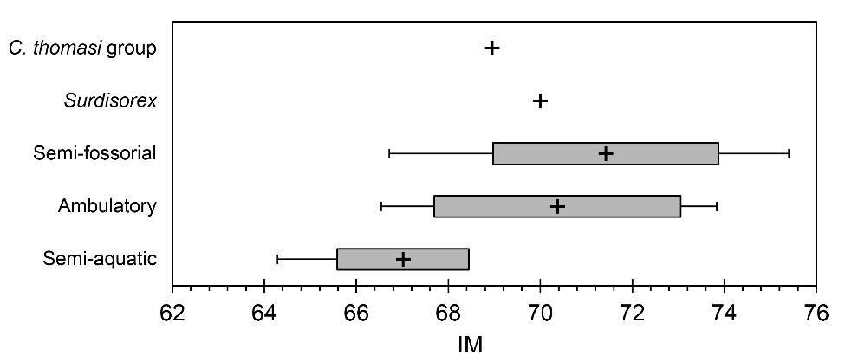
b. HFI
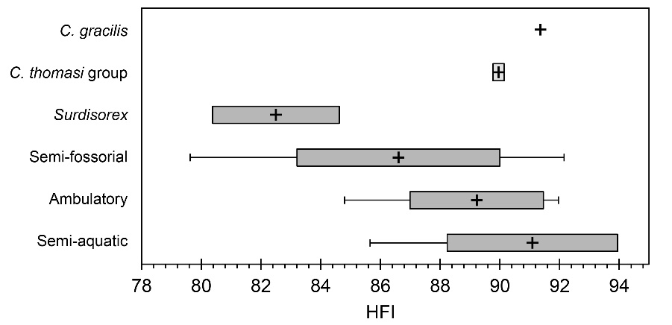
c. FOOT
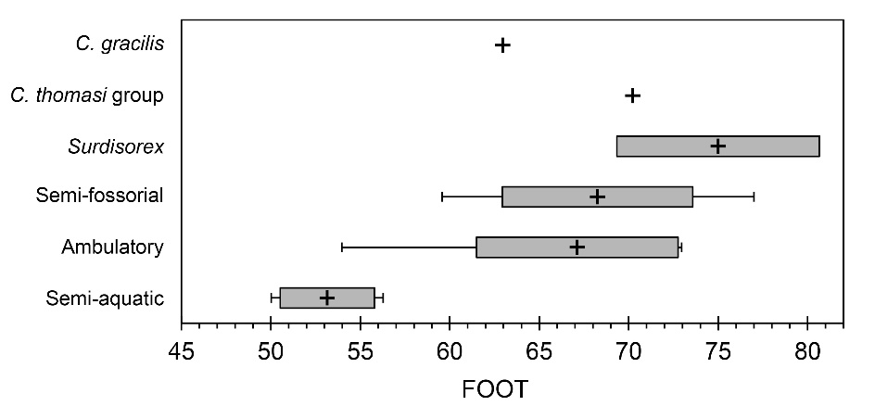
d. CLAW
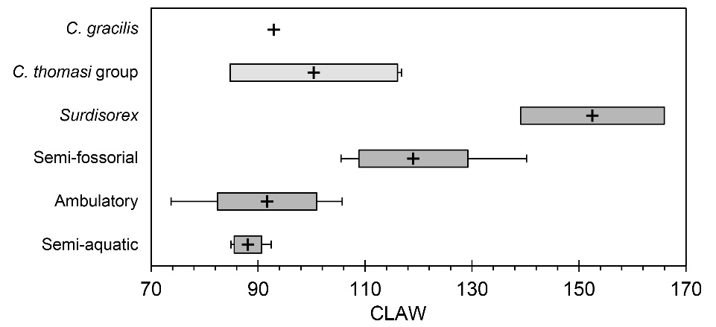
e. CLI
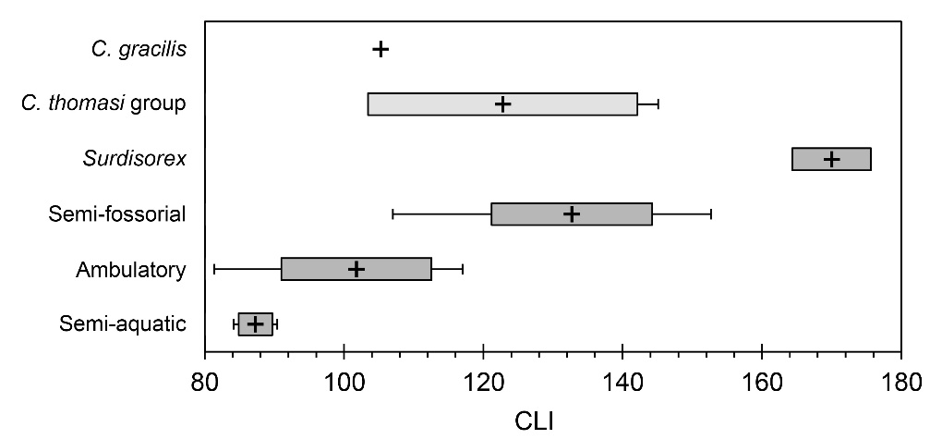
f. SHI
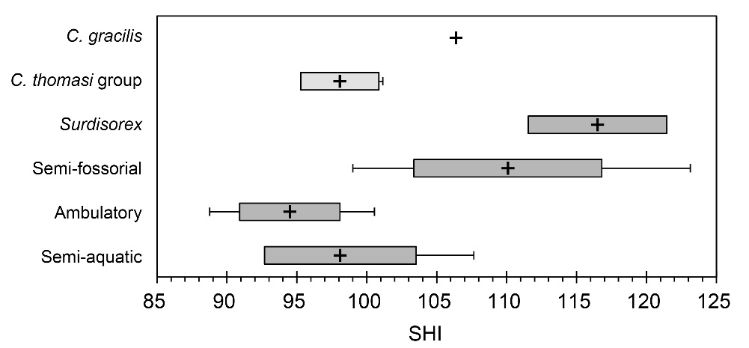
g. BI
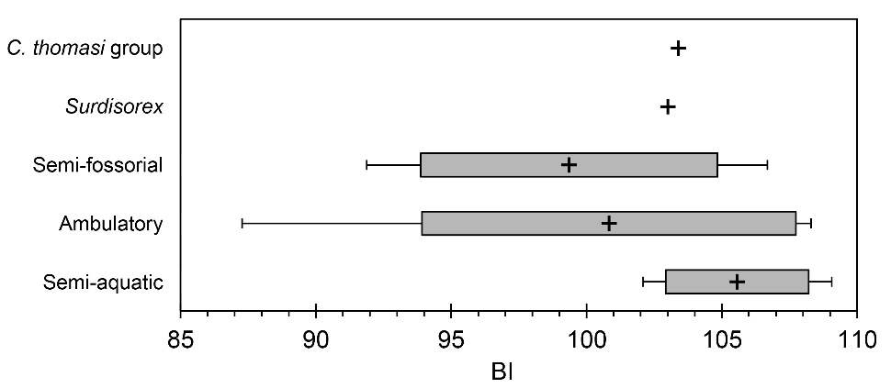
h. SMI
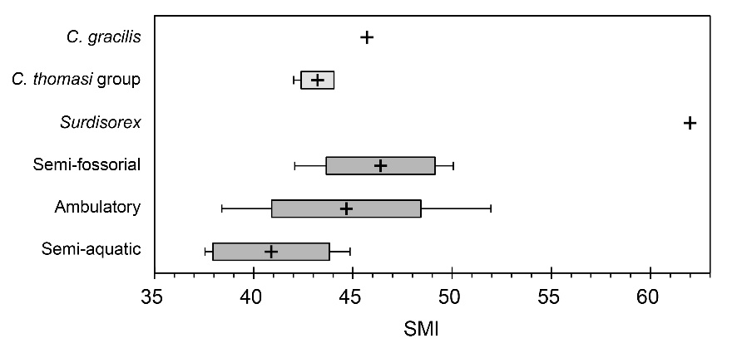
i. HRI
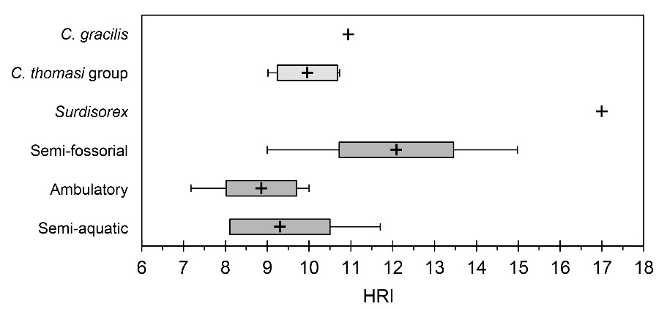

j. HTI
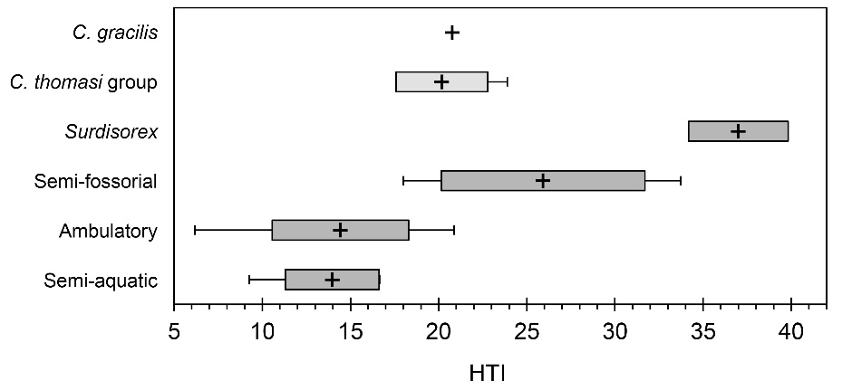

k. TTP
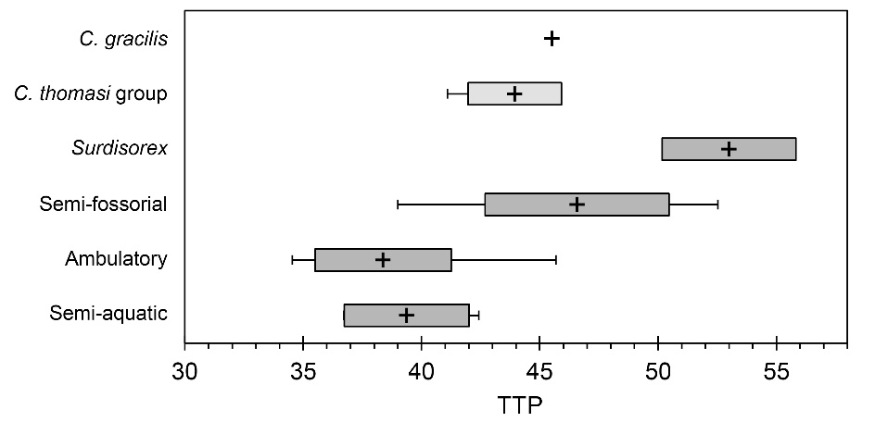

l. HEB
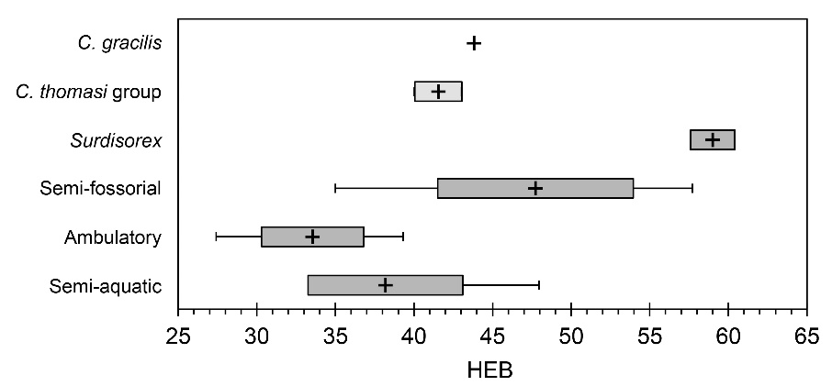

m. RDW
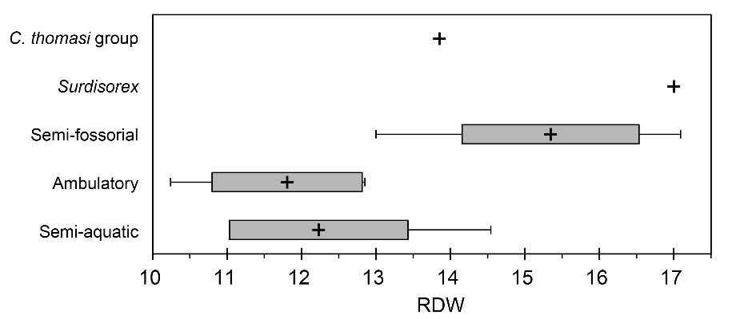

n. OLI
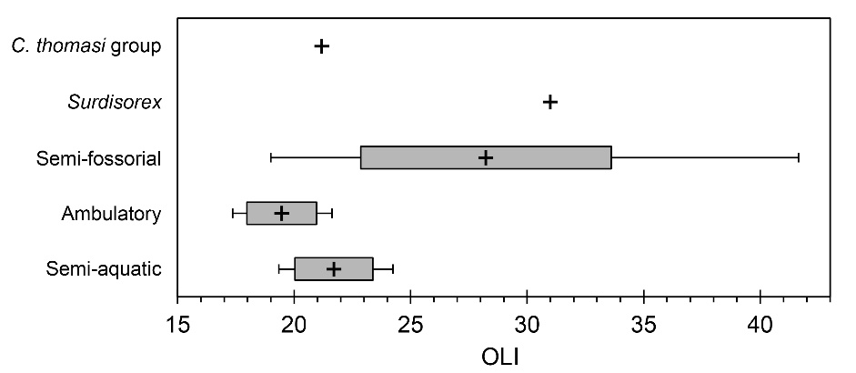

o. TMO
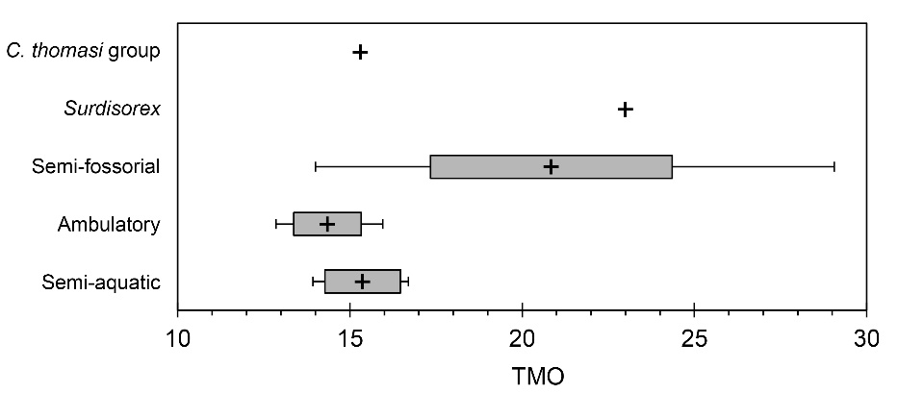
p. TCO
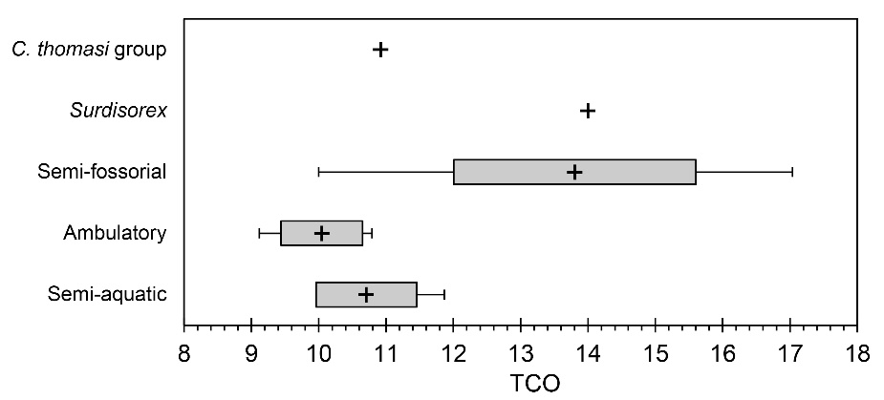

q. OCI
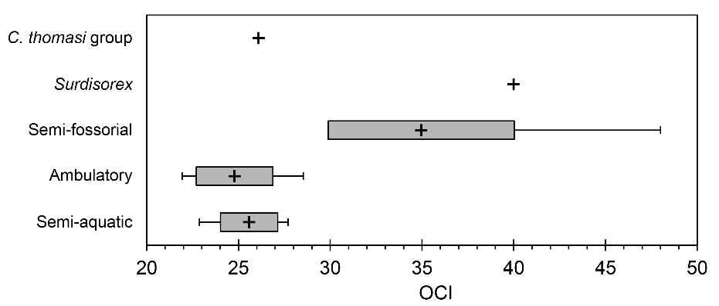

r. URI
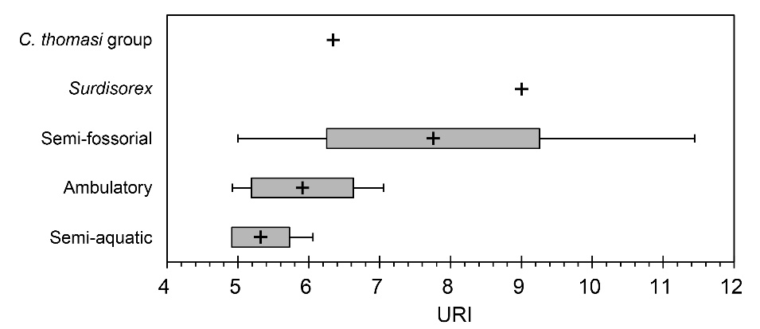

s. %DPL
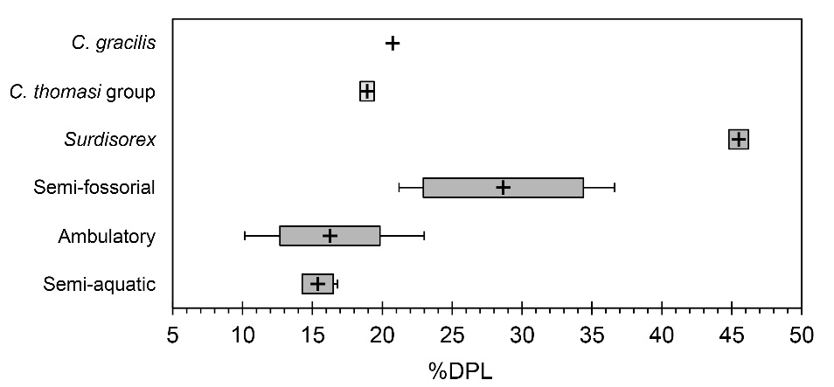
t. %CL
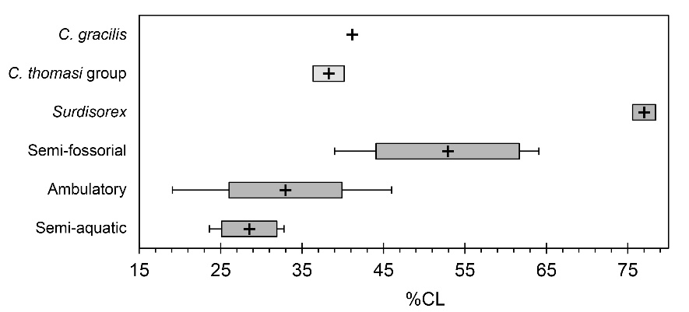

u. %CLS
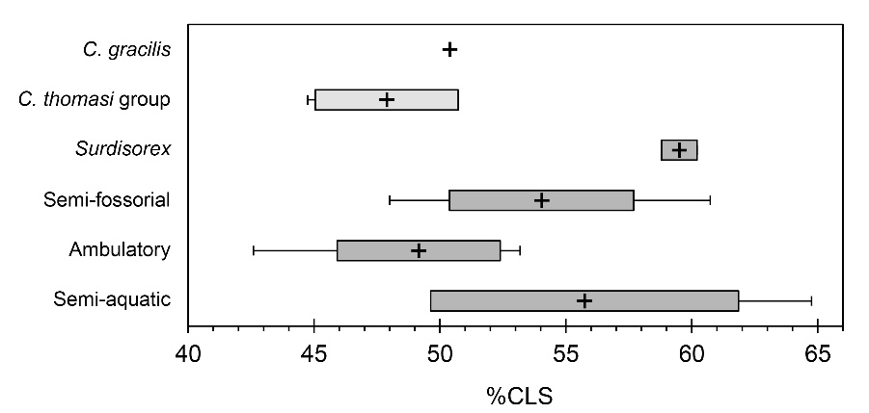

v. MW3
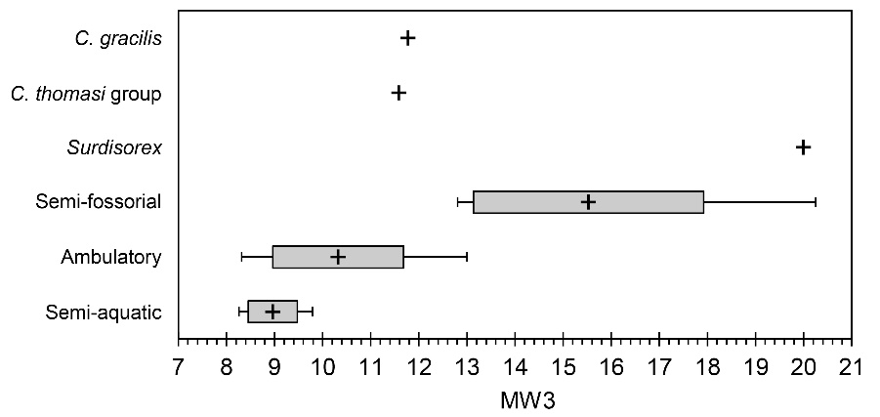

w. PI
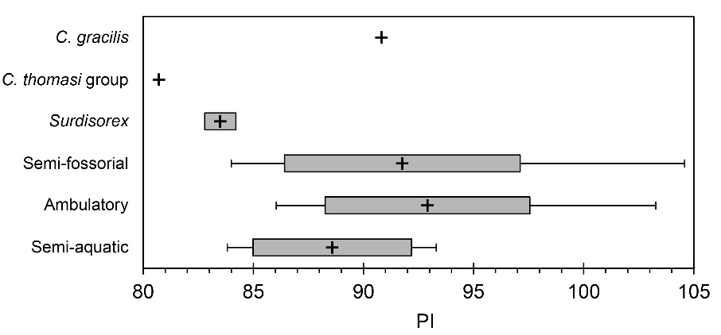

x. MANUS
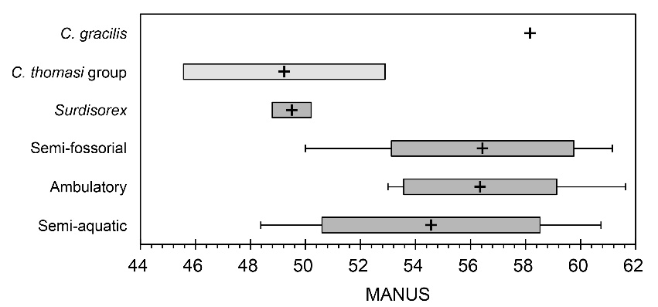
y. CI
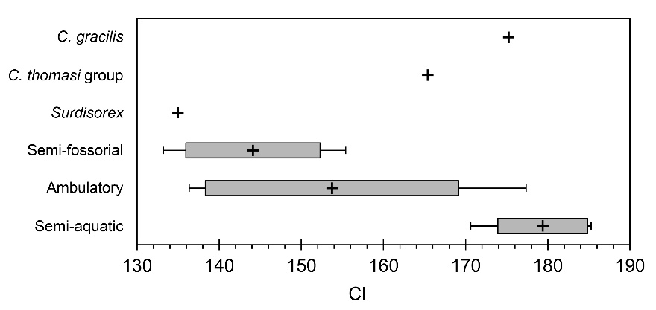

z. PES
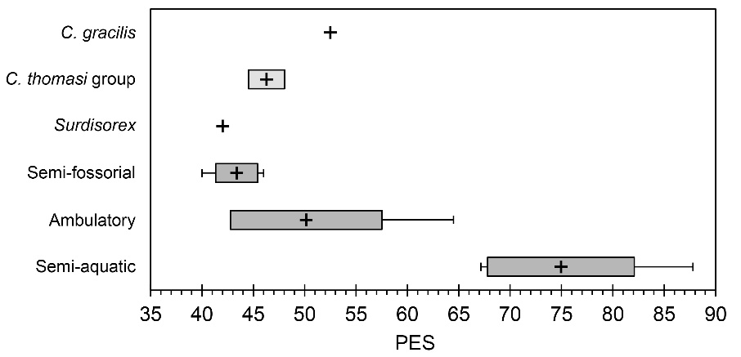

α. FRI
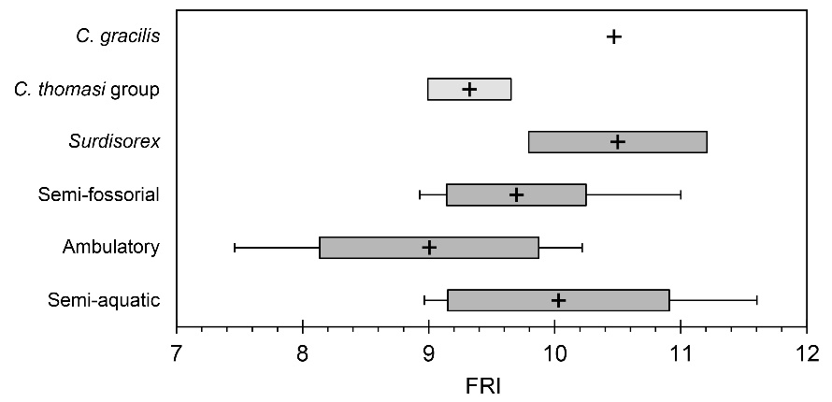

β. FEB
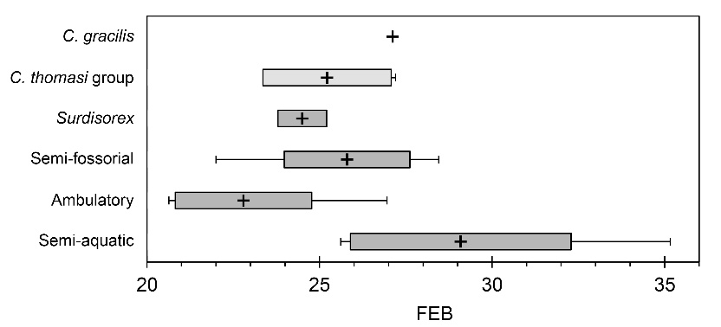

γ. DTA
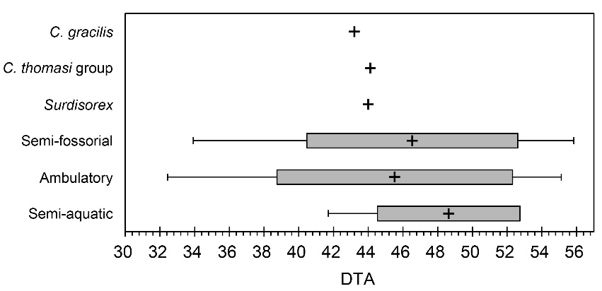

δ. %hDPL
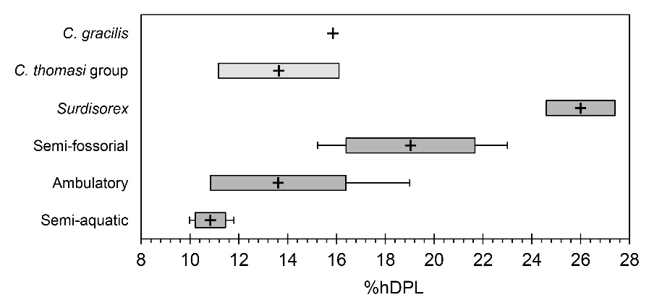

ε. %hCL
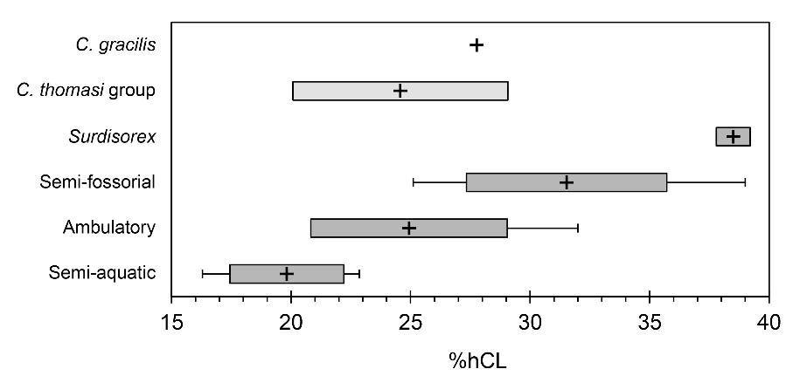

ζ. %hCLS
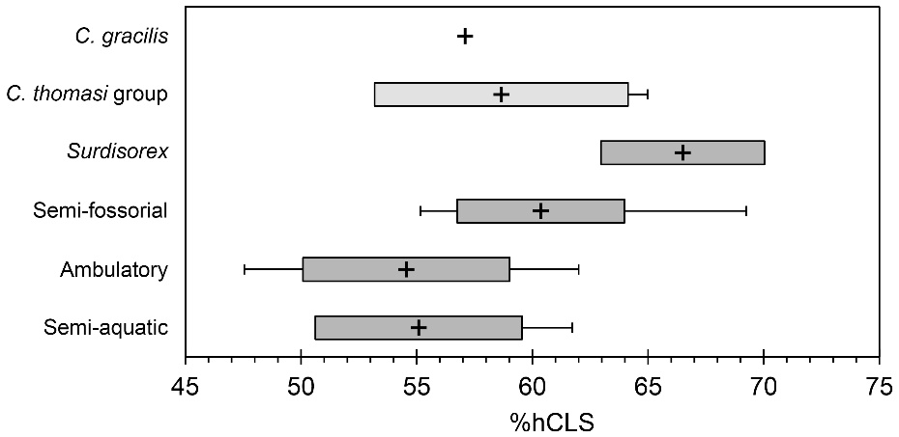

η. %TAIL
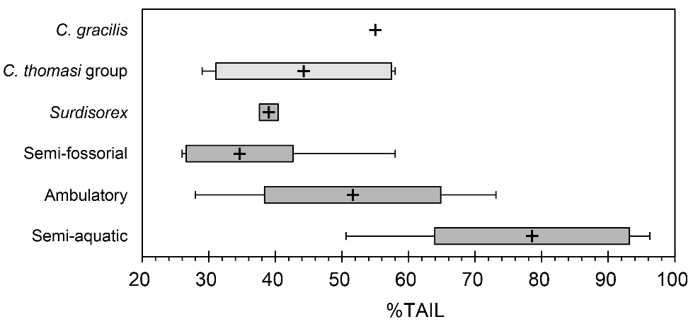

θ. RR
